Progetto di Ingegneria del software

Anno accademico 2018/2019



*Carcheck*



|  |  |  |
| --- | --- | --- |
| **Tabella Componenti** | | |
| **Capriglione** | **Francesco** | 0512104540 |
| **D’Auria** | **Aldo** | 0512104594 |
| **De Falco** | **Daniele** | 0512104666 |
| **Iacovazzo** | **Giovanni** | 0512104774 |

**1. Test di unità**

**1.1 AddressManager**

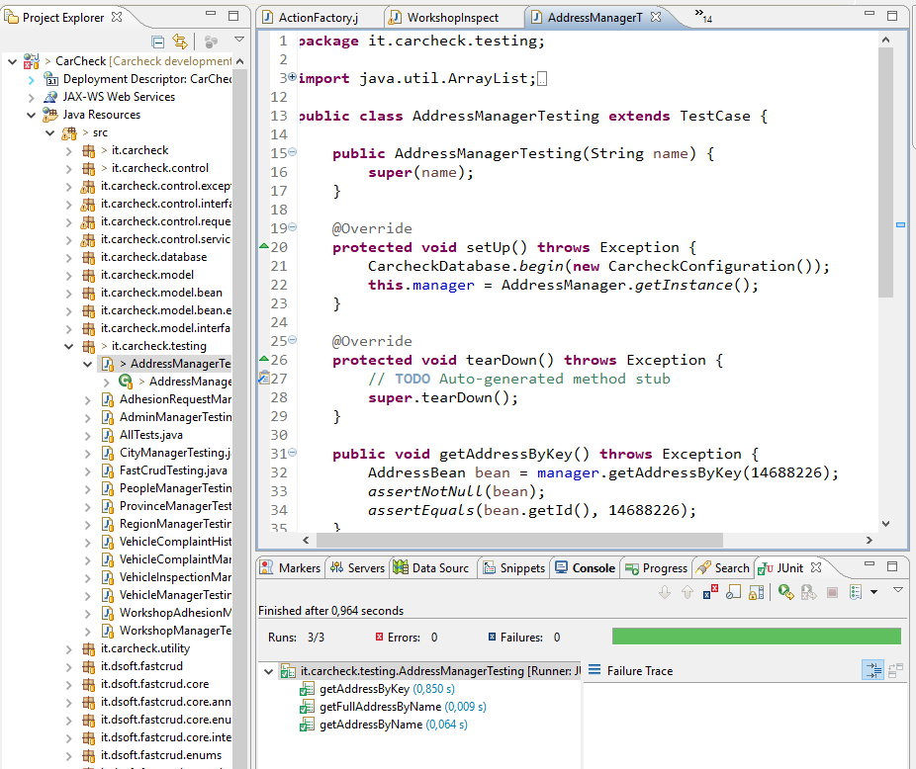

**1.2 AdhesionRequestManager**

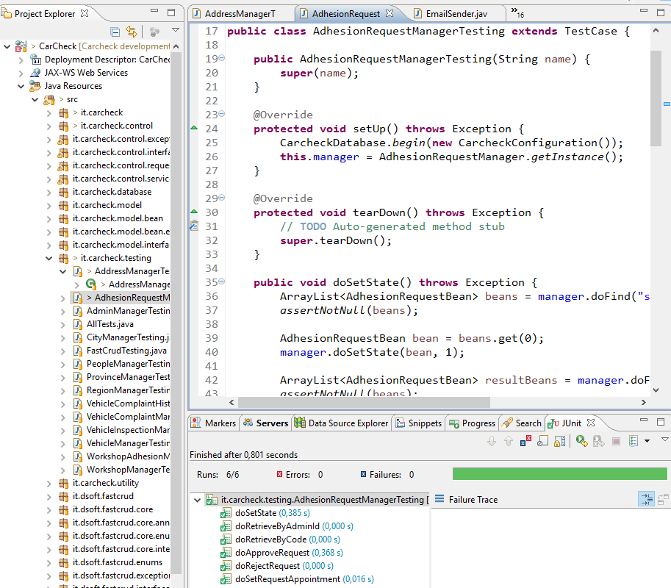

**1.3 AdminManager**

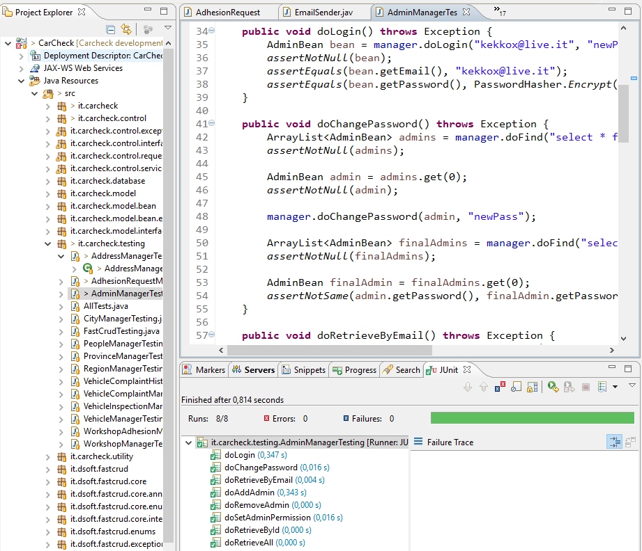

**1.4 CityManager**

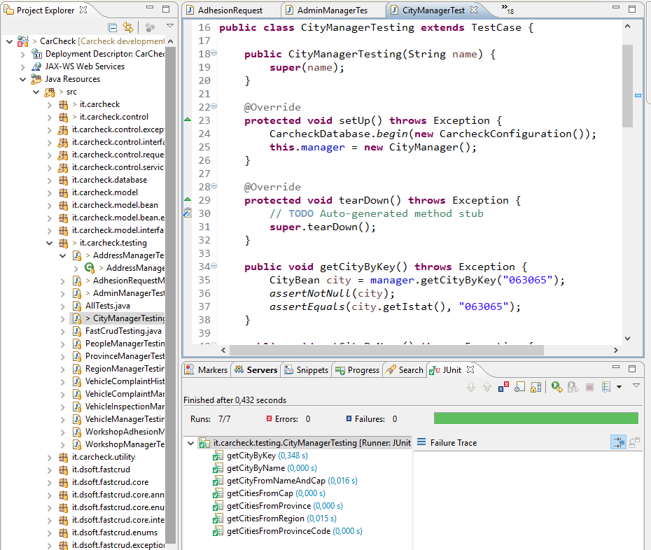

**1.5 FastCrud**

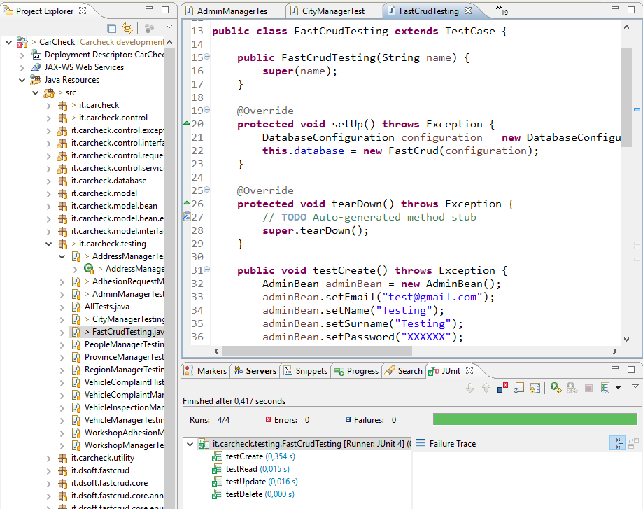

**1.6 PeopleManager**

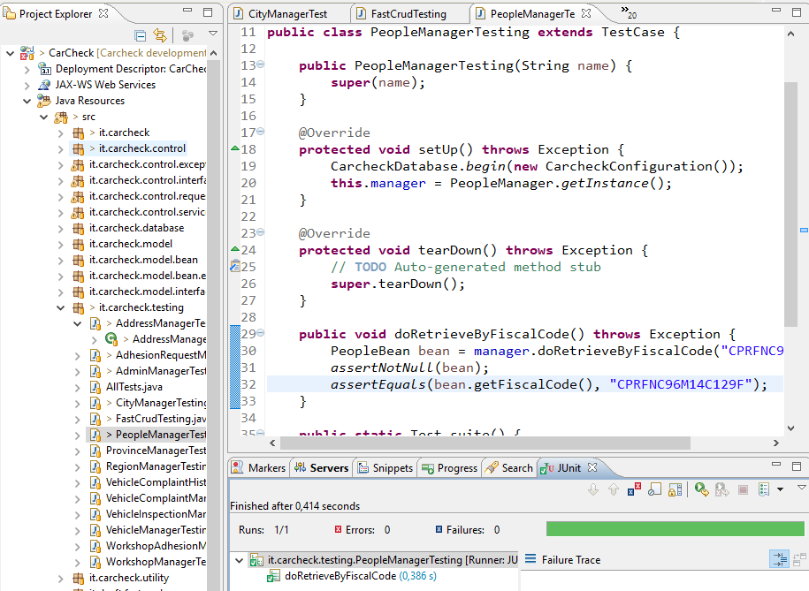

**1.7 ProvinceManager**

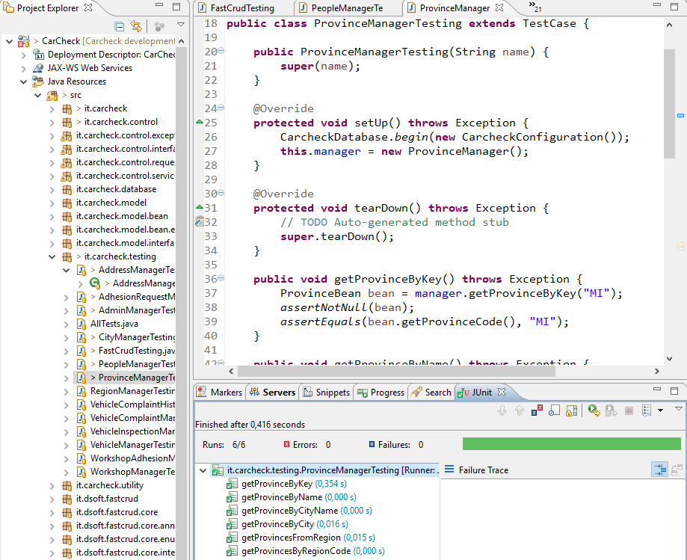

**1.8 RegionManager**

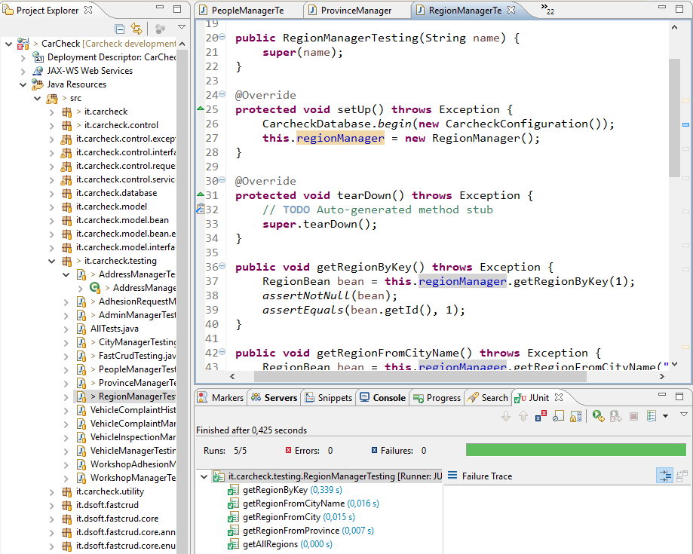

**1.9 VehicleComplaintHistoryManager**

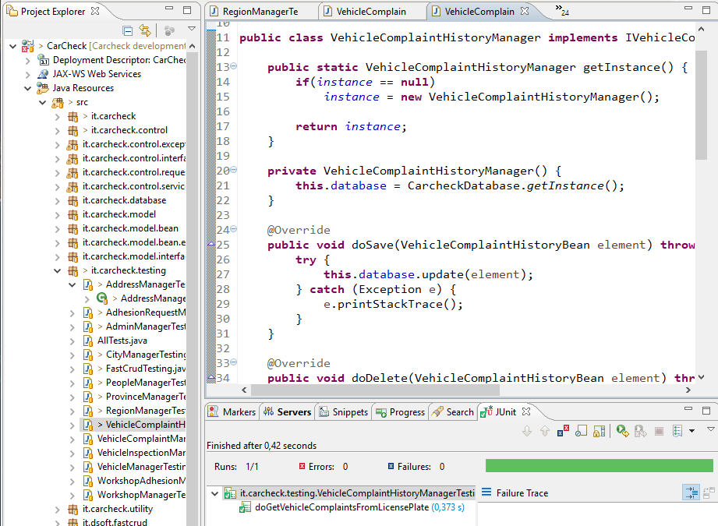

**1.10 VehicleComplaintManager**

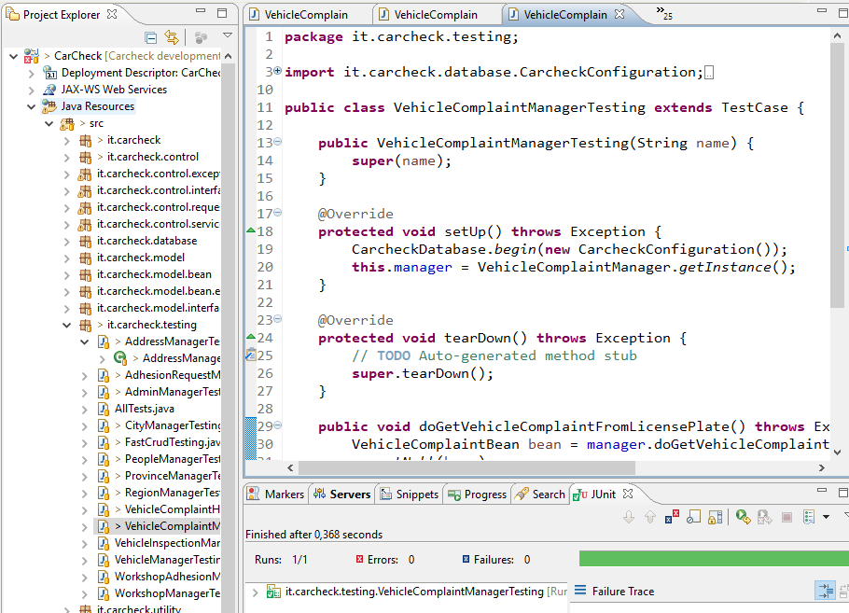

**1.11 VehicleInspectionManager**

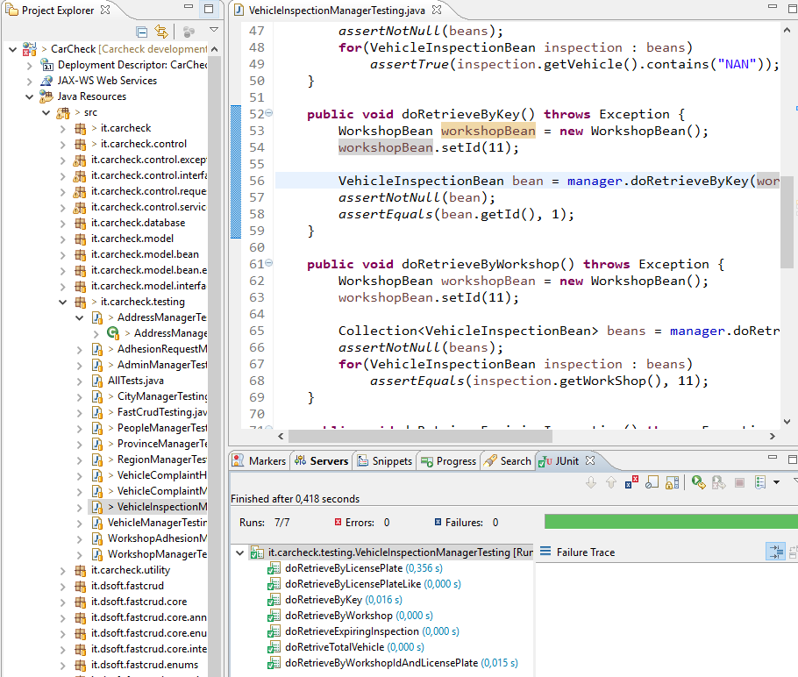

**1.12 VehicleManager**

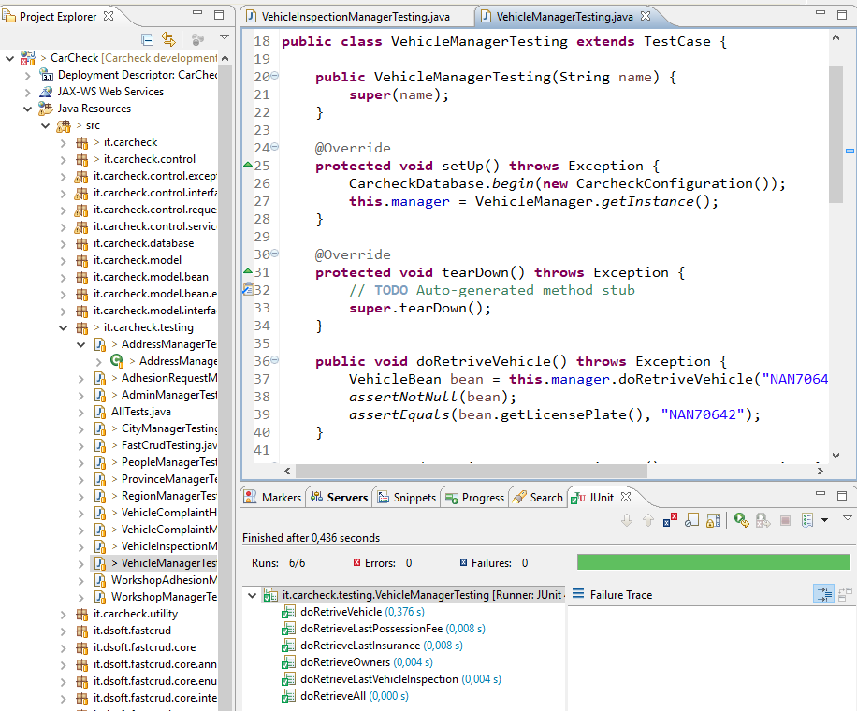

**1.13 WorkshopManager**

